13DTP Python Arcade Licensing
For the background images:
Parallax Cave Background Assets
Created by SlashDashGamesStudio
Art made by Seetyaji
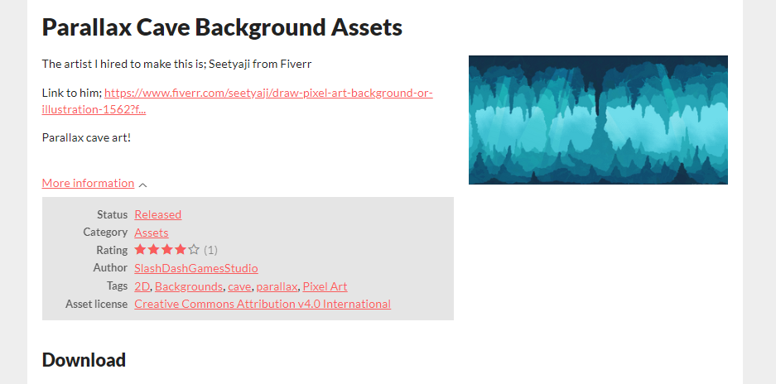
Licensing for the asset: Creative Commons Attribution v4.0 International
https://creativecommons.org/licenses/by/4.0/deed.en
Link to website in image –
https://slashdashgamesstudio.itch.io/cave-background-assets
Link to fiverr of artist –
https://www.fiverr.com/seetyaji/draw-pixel-art-background-or-illustration-1562?funnel=95a4d0bab562dfd3589a6519ac66754b

Other sprites (tiles, player, and magma) were all made by me, using piskel –
https://www.piskelapp.com/
The music and audio used were made by friends, who gave me permission to use them –
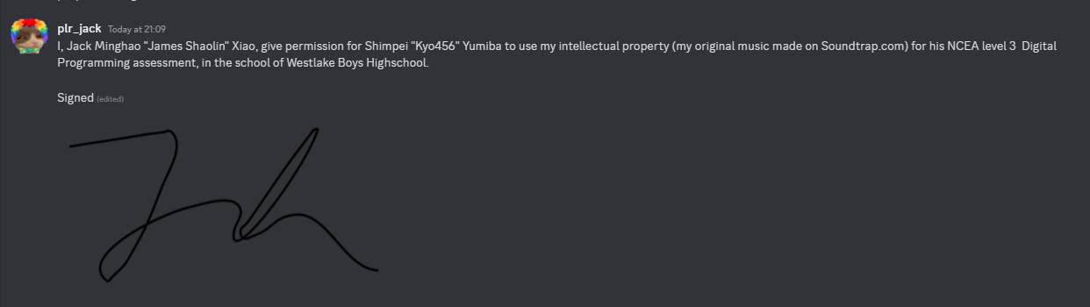
- Made both the menu and level music

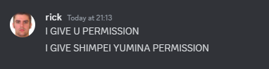
- Made the checkpoint audio
- (he was at work so this was the best he could do)

